Activity: Trusting Fictional Characters

Pick 3 fictional characters and calculate their trust scores

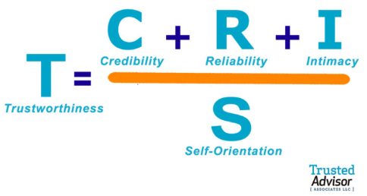

Marvel

Wolverine

Deadpool

Iron Man

Captain America

Loki

DC

Superman

Wonder Woman

Batman

Harley Quinn

Lex Luthor

Lord of the Rings

Gandalf

Frodo Baggins

Legolas

Aragorn

Samwise Gamgee

Star Wars

Luke Skywalker

Han Solo

Chewbacca

Leia Solo

Harry Potter

Harry Potter

Hermione Granger

Draco Malfoy

Hagrid

Sirius Black

Other Shows

Dr. House

Katniss Everdeen

Walter White

Sherlock Holmes

